ANNEX B: BARRIER TYPES

A list and brief description of additional types of river barriers and other features included in the survey.

**Dam**

A dam is a barrier that blocks or constrains the flow of water and raises the water level,

forming a reservoir. Dams come in many shapes and sizes. Dams are often used to provide

water supply and for generation of electricity. It causes a significant alteration of flow and

sediment discharges and a complete interception of bedload.

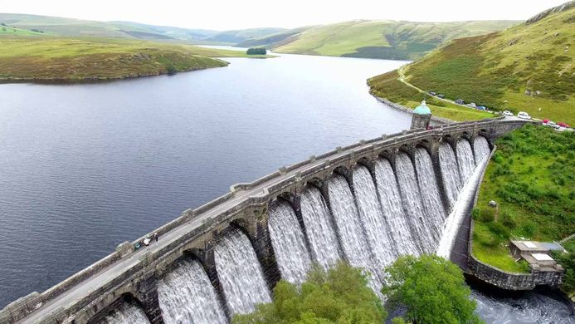

**Weir**

A weir is a barrier aimed at regulating flow conditions and water levels or at intercepting

sediment or at reducing the channel slope for stabilizing the channel bed of a river or

stream. Water often flows freely over the top of a weir. Weirs come in many shapes and

sizes (e.g. in mountain areas: retention and consolidation check dams; in lowland areas:

consolidation or abstraction weirs) but often have a height of less than 5 meter.

|  |  |
| --- | --- |
|  |  |

**Sluice**

A Sluice is a movable barrier aimed at controlling water levels and flow rates in rivers and

streams. By opening or closing the sluice, water levels and flow rates can be altered. Sluices

come in many shapes and sizes. Sluices are also used in ship locks, to allow ships to navigate

passed dams or other obstructions which create uneven levels of water.

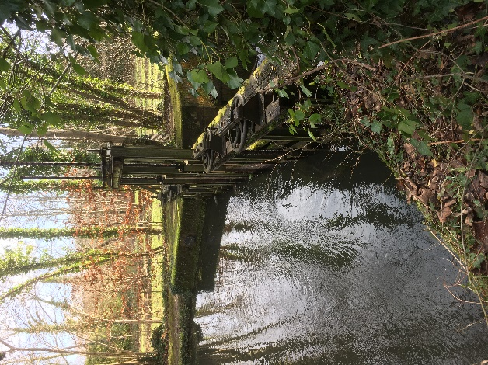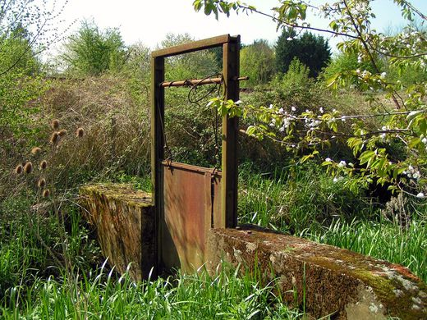

**Ford**

A Ford is a structure in a river or stream which creates a shallow place for crossing the river

or stream by wading.

|  |  |
| --- | --- |
|  |  |

**Culvert**

A Culvert is a structure aimed at carrying a stream or river under an obstruction. Culverts

are often embedded in soil and come in many shapes and sizes, varying from round and

elliptical to box-shaped.

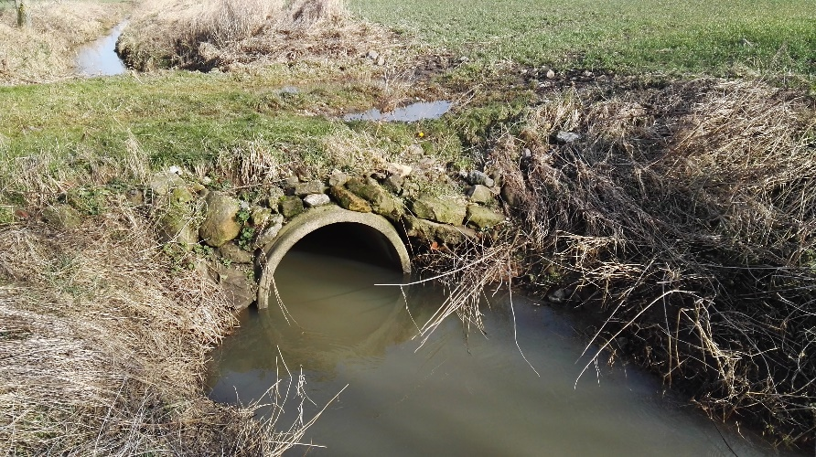

**Ramp and bed sill**

A Ramp or a bed sill is a structure aimed at stabilizing the channel bed and reducing erosion.

Ramps and bed sills come in many forms. They can be underwater structures (i.e. not

blocking the flow of water, only acting on river bed and channel slope) but often have a

height of less than 1-2 meters.

|  |  |
| --- | --- |
|  |  |

**Natural falls**

A natural fall is a structure formed of bedrock. They can vary in height from less than 0.5 to more than 10 meters.

|  |  |
| --- | --- |
|  |  |

**Point source pollution**

A point source of pollution is a single identifiable source of water pollution. A point source has negligible extent, distinguishing it from other pollution source geometries (such as nonpoint source or area source). Mine water pollution can be identified by the orange iron oxide present in the water and on the stream bed.

