River Afan barrier survey
Survey protocol for recording all artificial barriers in the Afan catchment
Josh Jones and Peter Jones, Swansea University
Companion documents:
- Annex A – shows layout of distinct survey reaches in Afan catchment
- Annex B – provides definitions to be used for categorising barrier type
- Annex C – field proforma to be filled out as a backup to using Barrier tracker
- Annex D – generic risk assessment
- Annex E – instructions on how to install and use Barrier Tracker app
- Annex F – Equipment check list
Research justification
The objective of this survey is to map all artificial barriers and point sources of pollution within the Afan catchment. It is part of Swansea University’s AMBER project (Adaptive Management of Barriers in European Rivers), which aims to assess the effect of artificial barriers of river ecosystems across Europe. More information can be found here: https://portal.amber.international. The Afan catchment was chosen as it represents a feasible area to cover and contains a wide variety of land uses (urban/industrial/agricultural/forestry/rural) and historical industrial activities which are likely to affect barrier distributions and salmonid populations. Although much has been improved in recent years with regards to the legacy of industrial activities in the catchment pollution is still evident, with four out of the six Afan water bodies failing to meet the EC Water Framework Directive ecological targets for fish in 2015. The outputs of this survey will provide a unique opportunity examine the effect of physical and chemical barriers on river communities.
Field protocol
This survey will use the AMBER Barrier Tracker smartphone application specifically designed to map locations of barriers and collect basic information on barrier characteristics. Data collected on your phone are then uploaded to a central database containing barrier records across Europe. All field personnel should download Barrier Tracker in advance. Annex E provides information on how to install and use Barrier tracker. The Barrier Tracker still functions without phone signal, so you can use it to collect data and upload information later when you have signal. Table 1 specifies the variables to be collected during surveys. A good quality photo should be taken with your phone camera, showing the entire barrier from downstream, if safe to do so. Location is collected using your phone GPS so you will have to allow the app to use your location. Definitions of each barrier type are provided in Annex B. Barrier heights should be measured by eye, from the water level downstream to the top of the barrier. Barrier use is whether the barrier is still in use or not. This can be difficult to tell, especially with older structures, so if in doubt, select ‘don’t know’. Finally, you must state whether the barrier spans the entire river width or not. Pollution sources such as sewage overflows and mine water pollution should be recorded as other. Should the battery of the individuals/team’s smartphones run out they should use a GPS device to record the ordnance survey (OS) grid reference for each barrier and add information to proforma given in Annex C. In the cases where GPS signal is poor or unavailable teams shall record the OS grid reference on the 1:25000 map sheets provided. We also suggest that each surveyor downloads a free app called Viewranger and use the base maps to keep track of their location during surveys.
Table 1. Variables to recorded for each barrier via the Barrier Tracker app
Name | Description
Picture | A photo of the barrier provide a reference for the picture
Location | Lat/Long coordinates for e.g. via GPS chipset on phone or GPS device
Date | Date of record in format day/month/year
Barrier type | Dam, weir, culvert, ford, ramp and bed sill, sluice, unknown
Barrier height | <0.5 m, 0.5 - 1.0 m, 1.0 - 2.0 m, 2.0 - 5.0 m, 5.0 - 10.0 m, >10.0 m
Barrier use | Barrier still useful/in-use, Y/N/don’t know
Barrier width | Full width, Y/N

Survey teams will do walkover surveys over the entire river length shown in Annex A, recording every barrier that spans >90% of the river channel and causes a head difference in water level, no matter how small and incidence of mine water pollution or other point source pollution (see Annex B for details). The total length of the Afan catchment is 220km. It has been divided into c.1 km sections (see Annex A), so that surveyors can choose sections that suit them. Before conducting surveys teams must indicate via the spreadsheet, that accompanies the map shown in Annex A (www.reconnectingourriver.org), which sections they intend to cover so that there is no duplication of effort. When selecting sections surveyors start at the downstream-most point and working progressively upstream where possible. In some locations progress may be slow due to difficult terrain, so please only cover what is safe to do so. In other areas, you may find you can easily cover more than the distance you indicated before heading out in a day, so may be able to start another section, but in this case please keep strict records of start/end locations. In headwater tributaries, surveyors may find that streams delineated in the survey maps decline to a size where they are insignificant and difficult to follow. Hence, the upstream limit set is where stream width is on average less than 0.25 m.
All surveys should be undertaken during low flows in summer months (May - September 2019). River levels can be checked prior to surveying here - https://rloi.naturalresources.wales/ViewDetails?station=4092. Surveys should only be carried our when river levels are <0.3m at the Cwmafan station. Field personnel should make sure they are familiar with protocols before going out, and read and sign the risk assessment (Annex D) before undertaking any work. Dynamic risk assessments should also be completed (Annex D) where any additional risks are identified. Personnel should inform Swansea University staff (Josh Jones and Peter Jones) of which survey reach they are covering each day by email. If there are any changes to the plan, please make sure you notify a staff member. An equipment list is provided in Annex F. Field teams should not access private property without permission. Land ownership details can be researched online beforehand, or by asking locals in the area. Please be courteous and polite when dealing with members of the public, state briefly the purpose of the survey, and generally most people will grant access. However, if landowners decline access, please accept their decision.
Surveys will involve walking mainly along the river banks, but also the stream channel where view from the bank is not clear. Thick vegetation, steep banks and bankside structures can often obscure views of the river channel. Surveyors should endeavour to continuously cover the entire river channel, except where it is dangerous to do so. Teams will work in pairs and shall be responsible for their own logistics regarding transport at either end of the surveyed reach. We suggest either dropping one vehicle at the end of the survey before returning to the start in another vehicle or using a vehicle that at least two team members can drive and drop the first person at the start, with a spare key, before the second drives to the half way point of the survey.
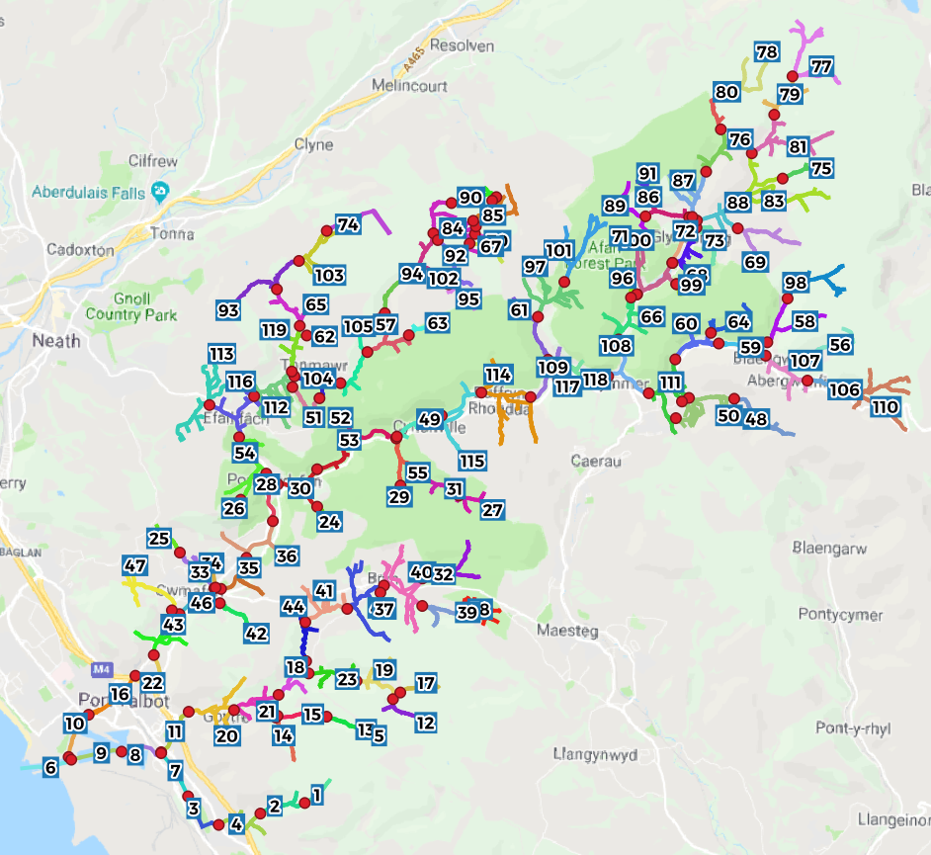
Figure 1 Overview of Afan catchment divided into c.1 km reaches
At the end of each survey day, teams should submit all barrier records via the app if stored offline and provide any barriers recorded by hand to Josh Jones or Peter Jones. If multiple field teams are working at the same time, then they should provide other teams (as well as Swansea University staff) with daily updates of area covered and inform them of their survey plans for the following day. Please keep Josh Jones and Peter Jones regularly updated regarding survey progress. If anything is unclear, or any problems are encountered, please let Josh Jones or Peter Jones know as soon as possible.

Summary and checklist
Before commencing survey
- Install and familiarise with Barrier Tracker app – Annex E
- Familiarise with barrier types – Annex B
- Check water levels <0.3 m - https://rloi.naturalresources.wales/ViewDetails?station=4092
- Read and sign the generic risk assessment - Annex D
- Dynamic risk assessments should also be completed - Annex D
- Inform Swansea University (SU) staff (Josh Jones and Peter Jones) of survey reach to be covered each day
- Check equipment list - Annex F
- Check land ownership details or locals in the area
- Install Viewranger and load base maps
During survey
- Report changes to the plan back to SU
- Respect private property
After survey
- Submit all barrier records via the app if stored offline on Barrier Tracker app
- Provide any barriers recorded by hand to Josh Jones or Peter Jones.
- Provide other teams (if any) and SU staff with daily updates of area covered, and survey plans for the following day.
Contacts
Josh Jones - j.a.h.jones@swansea.ac.uk 01792 295377
Peter Jones - p.e.jones@swansea.ac.uk 01792 518635

